US EPA’s Graded Approach
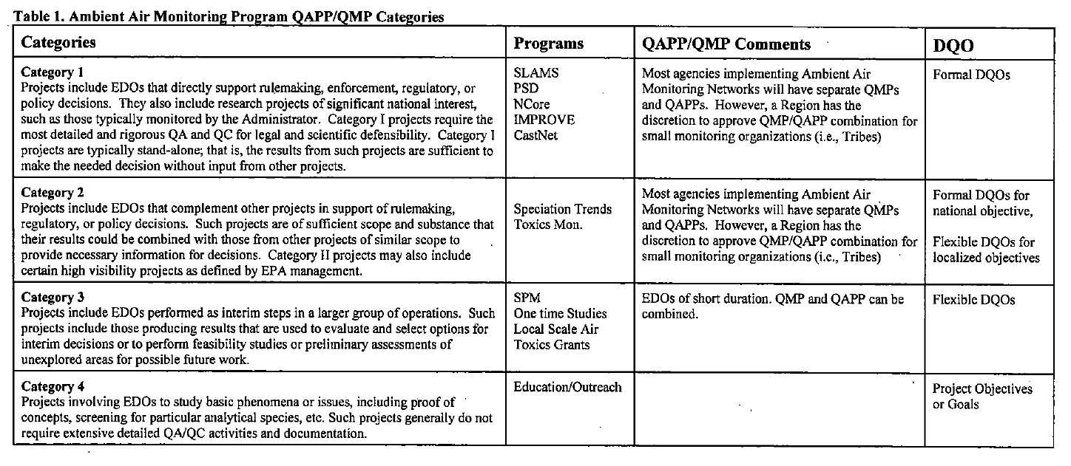
Your project may not involve extensive monitoring, or it may not involve any monitoring at all, such as if you are starting an indoor air quality program and will be doing building inspections to search for signs of mold or other indoor air pollutants (basis of visual inspections). Because there are so many kinds of environmental projects, the US EPA has developed a “graded approach” to QAPPs. This approach provides guidance on which QAPP elements are required for what sorts of projects. That guidance is provided as Appendix C of the US EPA’s QA Handbook Vol. 2, which is a useful reference if you are doing air monitoring: https://www3.epa.gov/ttn/amtic/qalist.html. Download the file: QA Handbook for Air Pollution Measurement Systems: "Volume II: Ambient Air Quality Monitoring Program" EPA-454/B-17-001. (Note that there is a critical section of the QA Handbook Vol. 2 that is updated often, sometimes as frequently as every six months. This section is Appendix D, the “validation templates,” which lists the required QC if you are monitoring to compare against the NAAQS, as well as other vital links and information. The most up-to-date version of those tables can be downloaded as their own link on that same page: QA Handbook Appendix D Validation Templates.)
EPA describes this graded approach as: “Since EPA funds the collection and use of data for a number of monitoring objectives and for organizations with a broad range of capabilities, flexibility in the QMP and QAPP requirements is necessary. For example, data collection for the purpose of comparison to the National Ambient Air Quality Standards (NAAQS) will require more stringent requirements, while monitoring programs for special purposes may not require the same level of quality assurance. The level of detail of QMPs and QAPPs, as explained by the EPA Quality Staff in the EPA Quality Manual, “should be based on a common sense, graded approach that establishes the QA and QC requirements commensurate with the importance of the work, available resources, and the unique needs of the organization.” The table reproduced here is from Appendix C of the QA Handbook Vol. 2, which should be used when evaluating what level of QAPP is appropriate for your project, in consultation with (if relevant) your funding agency or other partners in the project.
